**Tuesday** (Sara Lee)

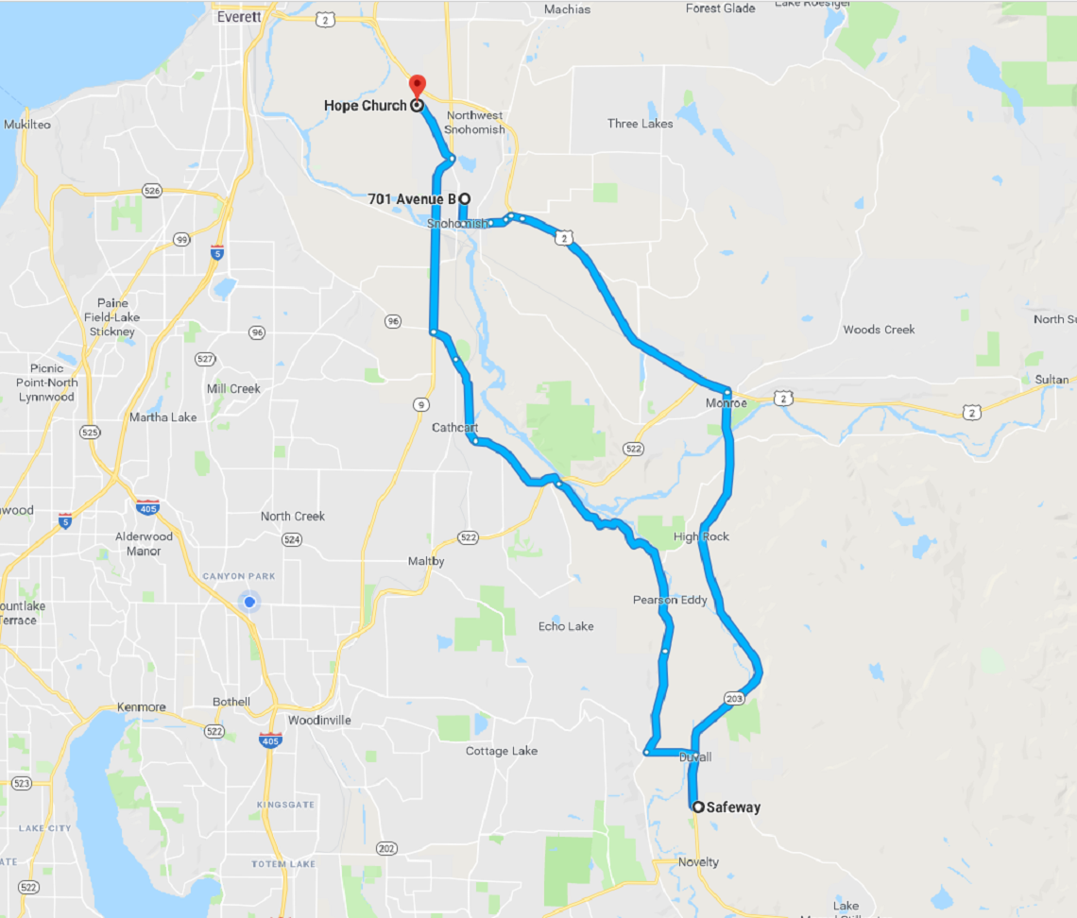

Notes: